MILESTONE ACADEMY
VACATION HOMEWORK
CLASS-VII
PC/MS/2019-20/VII/049
--------------------------------------------------------------------------------------------------------------------------------------------
ENGLISH-
- Write a paragraph on the topic ‘Education system in India’. (200 words)
- Make a chart on the following topic:-
- Determiners c) Modals
- Simple Future Tense d) Conjunctions
- Cross word puzzle:-
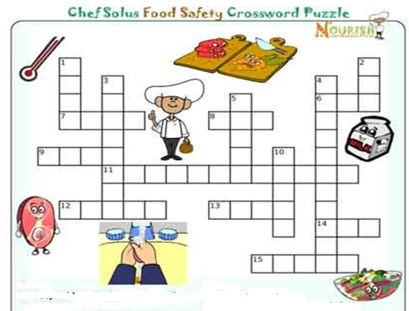

Across Down
6. Keep cold food cold and hot food ________ 1. Warm water and ___________
7. An ice _______ will keep your lunch cold. 2. Raw meat should _______ touch fruit
8. Wash your hand before you ________. 3. Germs is another word for ________.
9. Bacteria grown rapidly in the danger _______ 4. Use a meat __________ to check the
(Rhymes with cone) temperature.
11. Milk, eggs are yogurt should be stored in the 5. You can see bacteria : true or false
_______________ 10. Wash both of these for 20 seconds to kill germs.
12. Slice, Veggies on a clean cutting _________
13. Keep food __________ in the refrigerator
14. Bacteria begins to grow on perishable food with
in __________ hours if not refrigerated.
15. Don’t leave food out for more than two _______

G.SC-
I. Develop a model of Green House to know its importance.
II. Prepare a Herbarium of 8 different kinds of opened dried flowers to know its vegetative and reproductive parts.

PTO

MATHS-
1. Write about 4 different mathematicians and contribution towards Maths.
2. Find out the discount of any 5 articles you have purchased during festival. [Prepare a report]

S.SC-
I.Make a beautiful album showing the life style in Sahara Desert and Ladakh region.
2. Paste pictures of the two beasts of burden ie, Camel and Yak . Prepare a small report of the work of these animals
on their respective regions.

HINDI- 1- fojke fpg~uksa dks mnkgj.k lfgr fyf[k,A
2- fp=dyk çfr;ksfxrk esa Hkkx ysus gsrq Nk=ksa dks lwpuk nhft,A

SANSKRIT 1- dkjd jpuk & fde~ ] ;r~ ¼rhuksa fyaxks esa½
2- /kkrq:ikf.k& j{k~] ØhM~] ¼lHkh ikW¡pks ydkjksa esa½
3- /kkrq:ikf.k vkReusin& yHk~] ;kp~ ¼rhu ydkjksa esa½
4- vO;; dk vFkZ fyf[k, & iqu%] 'kuS%] iqjk] dqr%] brLrr%
5& vuqPNsn ys[kue~ & nhikoyh%

COMPUTER-
Make Presentation on Computer Virus and submit Hard copy
1. Introduction of Virus 2. Types of Virus 3. Virus Symptoms

LIFE SKILLS

Let’s make things better
This activity will help students to enhance identify their creative thinking + scientific skills. Choose any one of the following and think of practical ways, it can be improved
- Pencil
- Calculator
- Spoon
- Paper
- Postal system
- Tyres
- Lighting in a room
- Desk
- Bicycle
- Controlling a car

SUBMISSION DATE- 31/10/19

210

